How to make a button work

From Object Inspector

Select MainWindow

Right click and go to Change Signals and Slots

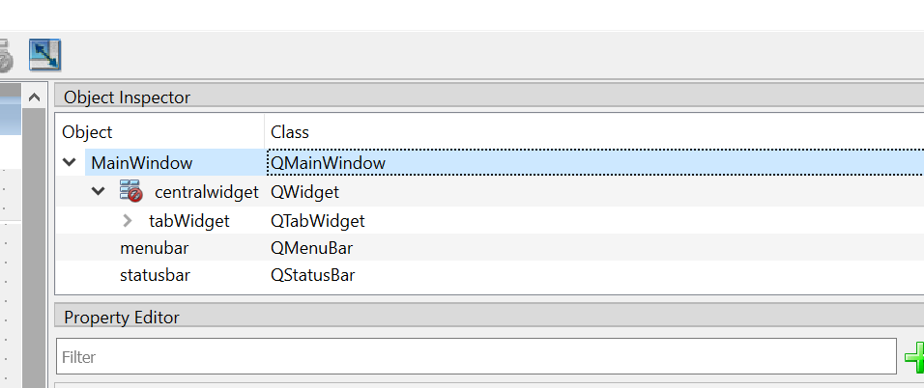

At the Signal/Slots popup add the new slot that corresponds to the name of the function to call

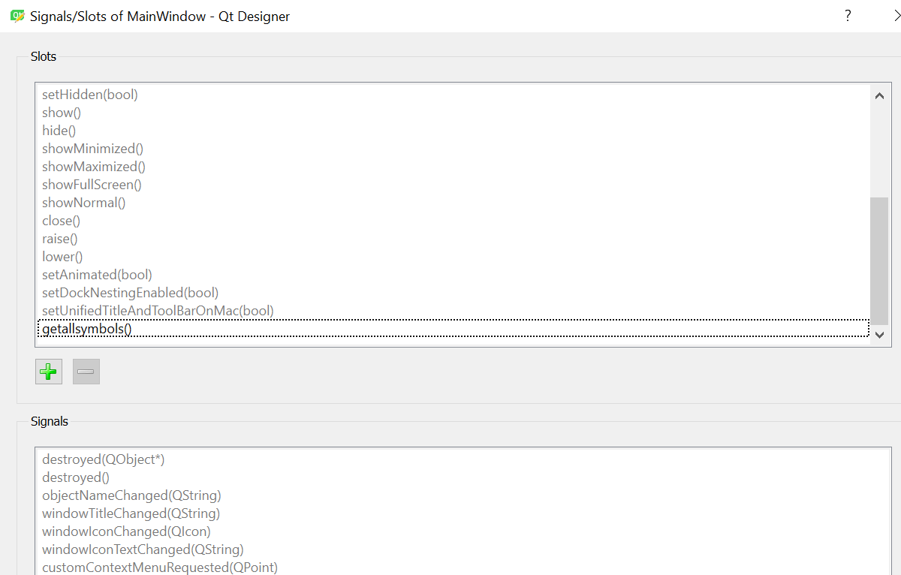

The function goes in the MainWindow Class

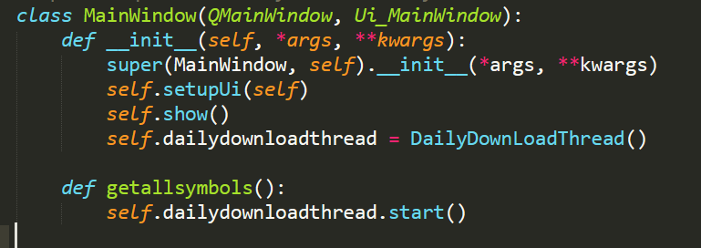

The class the has a run method that is the action that is performed on the button click

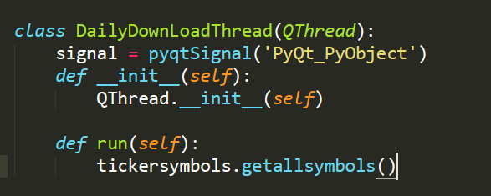

This is the location of the pipenv env

C:\Users\VH189DW\AppData\Local\Programs\Python\Python37\stockmarket

This is pulled from git

C:\Users\VH189DW\OneDrive - EY\GSA\UpDown\stockmarket



http://www.sublimetext.com/docs/2/indentation.html